## Overview

This document details the buildable area (BA) generation workflow for Acciona. Much of this doc was paraphrased from the “[Buildable Area Cheat Sheet_2023 (002)](https://patrickco.sharefile.com/d-s64608200d6b14cfb9bb9cdbee37661ee)” doc provided by Acciona.

**NOTES:**

* The “>” symbol means click. So “right-click Databases in the catalog pane > New File Geodatabase” means to click New File Geodatabase after right-clicking “Databases” in the catalog pane.

## Get project spatial reference information

In this step you’ll set the map’s Coordinate Reference System (CRS)… ***Learn more about CRS*** [***here***](https://pro.arcgis.com/en/pro-app/latest/help/mapping/properties/specify-a-coordinate-system.htm)***.***

The CAD .dwg of the project should include the necessary spatial reference (SR) info in the bottom part of the screen.

**Use** [**this**](https://spatialreference.org/) **resource to search for the SR’s EPSG/WKID code (unique identifier)**

1. Right-click “Map” in the Table of Contents (TOC) pane > “Properties” > “Coordinate Systems” tab
2. Search for the coordinate system found in the .dwg spatial reference by inserting it’s EPSG/WKID into the search bar
3. Once found, select it and > “OK”

## Create Geodatabase (GDB) to house project data

1. Right-click “Databases” in the Catalog pane > “New File Geodatabase (GDB)”
2. Navigate to where you’d like to save the GDB, give it a name, then > “OK”
   1. In this example, the GDB’s name is “BuildableAreaWalkthrough”
3. Right-click the new GDB in the catalog pane > “Make Default”

## Create Feature Datasets (FD) in the new GDB

1. Right-click the “BuildableAreaWalkthrough.gdb” in the catalog pane > “New” > “Feature Dataset”
2. Populate the tool parameters…

* 1. For the “Coordinate System” parameter, click the drop down arrow and select “Current Map [Map]”

1. Create a feature dataset for each data category (Land Control, Infrastructure, Transportation, Environmental, Cultural, and Buffers)
   1. I also like to make FD’s for buildable area (BuildableAreas), archived (ARCHIVE), and working (Working) features

## Import CAD to GDB

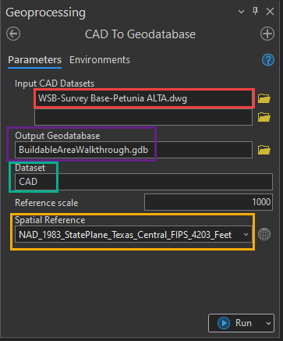

1. Open the “CAD to Geodatabase” geoprocessing (GP) tool and populate the parameters accordingly:
   * Input CAD Datasets: click the folder icon and navigate to the .dwg file > “OK”… or click and drag the .dwg from the catalog pane to the parameter entry box
   * Output Geodatabase: The GDB you want the CAD data to be saved to
   * Dataset: Name of the feature dataset that the imported data will reside in
   * Reference Scale: leave default
   * Spatial Reference: same as 2b in “Create Feature Datasets” section (select current map’s SR)
2. The .dwg data is now in GIS A screenshot of a computer program

   Description automatically generated
   1. ***NOTE:*** *Feel free to delete all feature classes (FC’s)* ***other than*** *“Point”, “Polyline”, “Polygon”, and “Annotation”*
3. Add the “Point”, “Polyline”, “Polygon”, and “Annotation” FC’s to the map table of contents (TOC)

## Extract target data

[Definition queries (DQ)](https://pro.arcgis.com/en/pro-app/latest/help/mapping/layer-properties/definition-query.htm) can be used to extract specific features from the imported CAD data.

In this example we’ll extract the transmission line from the “Polylines” CAD data.

1. Double-click the “Polygon” layer in the TOC > “Definition Query” tab > “New definition query” 
2. Fill out the DQ according to the screenshot below > “OK”

1. Select the transmission line features > right-click the “Polyline” layer in the TOC > “Data” > “Export Features”
2. Save the feature to the “BuildableAreaWalkthrough” GDB in the “Infrastructure” FD and name it “TransmissionLines”

**NOTES:**

* Definition queries limit the visible features to those that meet the query… So, in this case the only “Polyline” features that will be visible after clicking “OK” will be those with a “Layer” value of “VU-FIGR-ELEC-OVHD”
* The only buildable area features extracted from ALTA .dwg’s are:
  + Non-participating and participating parcels (project area)
  + Transmission lines
  + Pipelines (if present)
  + Overhead electric distribution (if present)
  + Water wells (if present)
  + Oils/gas wells/infrastructure (if present)
* **Repeat this process for each buildable area feature in the excel doc**

## Create buffers according to setback values

Next, we’ll create a buffer around the Transmission lines. The buffer distance is determined by the setback value in the buildable area excel document (provided by Acciona).

1. Open the excel doc and locate the transmission line row
   1. We’ll be using the 75-foot value since we’re working with centerline (CL) data
2. Open the “Pairwise Buffer” GP tool, fill in the parameters accordingly > “Run”:

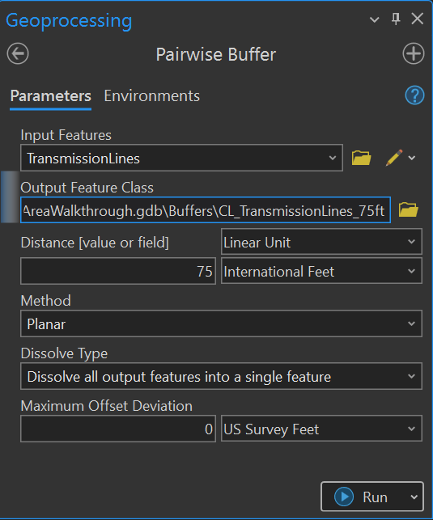

**NOTES:**

* **Repeat this process for each buildable area feature in the excel doc**

## Buildable area (BA) generation

Now that all the buffers (setbacks) have been created, you’ll generate the buildable area.

1. [**Merge** (Data Management)](https://pro.arcgis.com/en/pro-app/latest/tool-reference/data-management/merge.htm) all buffers/constraints that will be applied to the buildable area using the Merge GP tool
   1. Name the output “Merge”

1. [**Clip** (Analysis)](https://pro.arcgis.com/en/pro-app/latest/tool-reference/analysis/clip.htm) the newly created “Merge” layer to the “Project area” layer.
   1. Name the output “Erase”

1. Run an [**Intersect** (Analysis)](https://pro.arcgis.com/en/pro-app/latest/tool-reference/analysis/intersect.htm) between the newly created “Erase” and the “Project area” layers.
   1. Name the output “Intersect”

1. Run a [**Union** (Analysis)](https://pro.arcgis.com/en/pro-app/latest/tool-reference/analysis/union.htm) between the “Intersect” and the “Project area” layers.
   1. Name the output “Union”

1. Highlight the “Union” layer in the TOC > “Select by Location” in the “Map” tab, then populate the tool as followsA screenshot of a computer

   Description automatically generated

* 1. If present, remove any small residual polygon features

1. Open the “Union” feature’s attribute table and right-click on any field name > “Calculate Geometry” and populate as follows:

**NOTE:** This creates a new “CALC_ACREA” field in the union feature’s attribute table and populates it with the total acreage

1. Lastly, right-click the “Union” layer in the TOC > “Data” > “Export Features”
   1. Name the output “*ProjectName*_BuildableArea_YEARMONTHDAY”
      1. EX: Petunia_BuildableArea_20240516

**NOTES:**

* When running the “Select by Location” in step 5, using the “Within” relationship is not always required… you can just select the “Union” feature(s) with the largest “Shape_Area” value, as this feature corresponds to the buildable area.

## Buildable area generation (script tool)

I developed a python script tool that automates the process detailed in the “Buildable area generation” section.

In addition to that, the script tool also:

* Creates a “Working” feature dataset if it doesn’t already exist in the output GDB
* Explodes the output buildable area feature from [multi-part to single-part](https://pro.arcgis.com/en/pro-app/latest/tool-reference/data-management/multipart-to-singlepart.htm) before acreage calculation… this enables each feature geometry to have its own acreage value calculated
* Symbolizes the output buildable area feature according to a .lyrx file parameter input

1. **Output buildable area name (string):** Name of the output buildable area feature
2. **Input buffers (feature layer):** Buffers/features to be considered in buildable area generation (ALL MUST BE OF SAME GEOMETRY TYPE)
3. **Project area/Participating parcel (feature layer):** The project area
4. **Output symbology (layer file):** .lyrx symbology that the output buildable area feature will inherit
5. **Output GDB (workspace):** Output buildable area save location
6. **Spatial reference (spatial reference):** select the “Current Map” option from drop-down

**NOTES:**

* You can set default inputs by right-clicking the script > “Properties” > “Parameters”

## Export to KMZ and DWG

The final step is to export the newly generated buildable area feature to .kmz and .dwg formats.

### KMZ

1. Open the “Layer to KML” GP tool and fill out the parameters as follows > “Run”

### DWG

1. Open the “Export to CAD” GP tool and fill out the parameters as follows > “Run”

**TIP:** Before running,click the “Environments” tab and set the “Output Coordinate System” to the current maps

### KMZ automation

I developed a batch “FeatureToKMZ” script tool that crawls a GDB and creates a .kmz of each FC within… whether it’s in a FD or not. If the FC is in a FD, then it creates a folder in the directory specified by the user and names it according to the FD name. If the FC is not in a FD (is stand-alone), then the .kmz is saved directly to the directory.